Sri Lanka Institute of Information Technology

# Lab Submission

# Lab sheet No 05

**IT23756564**

**Karunaratne B.C.M.L**

**Probability and Statistics | IT2120**

B.Sc. (Hons) in Information Technology

Exercise 01.

02.





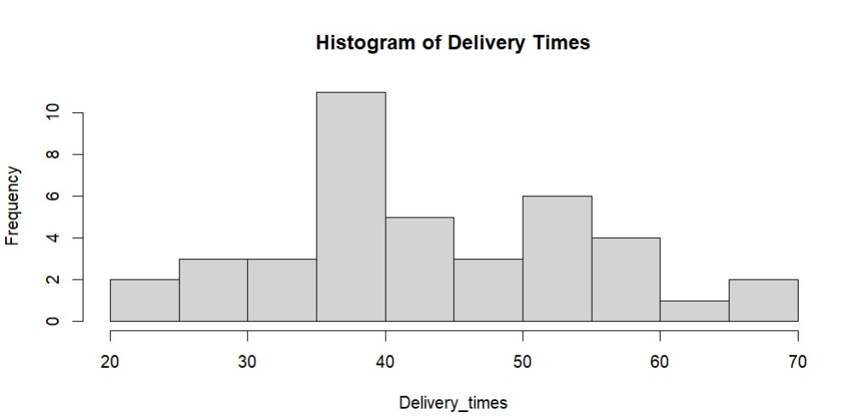

03. The distribution of delivery times is approximately symmetric and unimodal, with the peak around 35–40 minutes. It is not strongly skewed.

04.



